**Discovery Report**

ORIENT COMMERCIAL BANK

Way4 Implementation

|  |  |
| --- | --- |
| Prepared for : | ORIENT COMMERCIAL BANK |
| Version of Document : | 1.1 |
| Status : | Update |
| Release Date : | 23rd Oct 2020 |
| Prepared by : | Openway Asia |
| Author : |  |
| Owner : | Openway Asia |

# History of Changes

|  |  |  |  |  |
| --- | --- | --- | --- | --- |
| **Version** | **Date** | **Description** | **Author** | **Approved By** |
| 1.0 | 09.06.2018 | Initial Version. | Tu B. Nguyen |  |
| 1.1 | 03.11.2020 | Update Version. | Sang Tran |  |
|  |  |  |  |  |
|  |  |  |  |  |
|  |  |  |  |  |
|  |  |  |  |  |
|  |  |  |  |  |
|  |  |  |  |  |

Copyright

© OpenWay International Limited 2020. All rights reserved.

The Copyright of this complete document and every part it belongs to OpenWay International Limited. Proprietary material, brand or product names of other parties or trademarks remain with their respective owners. You may not, except with our express written permission, distribute or commercially exploit the content. Nor may you transmit it or store it in any other website or other form of electronic retrieval system. Any sample data used in examples below are completely fictitious unless otherwise noted.

Disclaimer

This document and the OpenWay International software it describes are furnished by OpenWay International Limited under a Software Licensing Agreement, Consultancy Agreement, Variation Request or Confidentiality Agreement, and may be used or copied only in accordance with the terms of such Agreement. Neither this document nor the OpenWay International software it describes may be used, sold, transferred, copied, translated, reproduced or transmitted in any form or by any means, electronic or mechanical, for any purpose, in whole or in part, other than in accordance with the terms of such Agreement, or otherwise without prior written consent of OpenWay International Limited.

This document describes a generic product or service and should be read in conjunction with other documents relevant to the configuration of any specific system. The licensee of OpenWay software or user of OpenWay International services is responsible for ensuring that the product or service described herein meets its own requirements. The information contained in this document is subject to change without notice and should not be taken as a commitment by OpenWay International Limited. OpenWay International Limited assumes no responsibility for any errors that may appear in this document.

Confidentiality

The information contained in this Document is the property of OpenWay International Ltd and contains CONFIDENTIAL information that is produced solely for the benefit of the receiving party named on the front page of this document. The recipient should keep this document and all its information confidential. On no account should this document, in whole or in part, be used, sold, transferred, copied, translated, reproduced or transmitted in any form or by any means, electronic or mechanical, or disclosed or disseminated to any third party, without the express written permission of OpenWay International Ltd.

Table of Contents

1 History of Changes 2

2 Introduction 4

2.1 Introduction 4

2.2 Notations used 4

2.3 Data Elements 5

3 Risk Management 6

3.1 Business Requirement 6

3.2 Technical Detail 7

3.3 Limitations 7

# Introduction

## Introduction

This document contains the risk rule to monitor online transaction which the Way4 system will be configured for the Business Requirements of Orient Commercial Bank. It covers the different sections of the Way4 system and Configuration needed to be done in them.

The technical solution, setup and configuration needed to be done in Way4 to satisfy risk rule requirements. These solutions are internal to Way4 and are based on expertise and knowledge of OpenWay staff. The solution will be updated and finalized during system build phase by OpenWay.

## Notations used

The formats of the file fields are as follows:

| Ref | Description |
| --- | --- |
| A | Alphabetic characters A through Z and a through z |
| N | Numeric digits 0 through 9. A numeric field containing only digits; the field is right-aligned and should to be appended with leading zeros to reach the specified length. |
| An | Alphabetic and Special Characters. A character field containing any printable characters; the field is left aligned, it is appended with trailing spaces to reach the specified length |
| Ns | Numeric and Special Characters |
| Ans | Alphabetic, Numeric and Special Characters |
| MM | Month, 01 through 12 |
| DD | Day, 01 through 31 |
| YY | Year, 00 through 99 |
| YYYY | Year, 0000 through 9999 |
| HH | Hour, 00 through 23 |
| MI | Minute, 00 through 59 |
| SS | Second, 00 through 59 |
| B | Binary representation of data. A binary field only used to store line delimiter characters |
| ..nn | Variable length data up to nn characters. There will be two or three character length (depending upon whether maximum data length is 99 or 999) at the beginning of the element to identify the number of positions following to the end of the data element |
| S | Single Value Field |
| MV | Multi-value Field/Multiline data |
| O | Optional |
| M | Mandatory |
| C | Conditional |
| MR | Copy from request |
| CR | Copy if present in request |
| ATM | Auto Teller Machine |
| CCDM | Cheque and Cash Deposit Machine |
| SML | SmartLink |
| Napas | Vietnam Nation Financial Switching Joint Stock Company |
| OCB | Orient Commercial Bank |

## Data Elements

The final component of a message consists of a number of 'data elements'. Data elements may be of fixed or variable length. No delimiters are used between data elements. Their order and presence is indexed by the associated bit map(s). Variable length data starts with length specified, indicating the length of that particular data element. Each data element is characterized by:

* **No** is a running number
* **Data Element Name** is name of field
* **Position** is starting position of the field.
* **Size** is the length of the field. For example: Position = 6 and length = 3 mean the field content starts at 6 spaces/ characters/ digits from the left and occupies 3 spaces/ characters/ digits.
* **M/C/O** is a value represents mandatory or conditional or optional. The following flags specify if the entry of data in the field is mandatory:
  + **M** - the data entry is mandatory,
  + **O**- the data entry is optional,
  + **C** - the data entry depends on other field values.
* **Description** is additional explanation of the field. It should clarify
  + whether the field is expecting a fixed value
  + the field is running number
  + the field existence depends on other field/ fields
  + termination symbol
  + delimiter; for example 0x0D, 0x0A (CRLF).

# Risk Management

## Business Requirement

**Real-time blocking:**

* System must be capable of blocking suspicious transactions identified by users including: MCC, Merchant ID (onus merchant+ offus merchant), TER ID, Acquirer BIN, Acquirer Country Code.
* System must be capable of blocking unsecured Ecommerce transactions: ECI 06, UCAF 01
* System must be capable of rejecting crossing border transactions (compare merchant country code of 2 continuous Card-Present transactions, if 2 transaction happen during a specific period of time, the later transaction will be declined).
* System must be capable of rejecting 2 transactions happening in very short time (compare date & time of 2 continuous Card-Present transactions, if 2 transaction happen during a specific duration of time, let’s say less than 1 minutes, the later transaction will be declined).
* System must be capable of rejecting transactions happening at multiple merchant, let’s say more than 2 merchants in very short time (compare Merchant ID of all Card not present transactions in a duration of time, let say 3 MID during 1 minute, the last transaction will be declined).
* System must be capable of blocking fallback/POS 01 transaction with pre-set limits.

**Risk scoring:**

* System should have risk scoring mechanism. When setting rule, user will decide the risk score of each rule. If transactions hit rules, the system will calculate the total risk scores of each alerts/cases based on all the rules being hit.
* Then when alerts/cases come out at every batch cycle, the screen will show the alerts/cases with highest risk scores on top of the screen so that analyst can pick up & handle first.

**Alerts/Warning:**

* System must be capable of generating SMS/Notification Email to Cardholder/User when creating alerts.
* System must be capable of scoring alerts based on pre-set risk scoring criteria

**Risk Rule Configuration**

Bank request Openway setup some risk rules:

Rule 1: Magnetic stripe card does the transaction on high risk group in USA with daily total amount >=10M

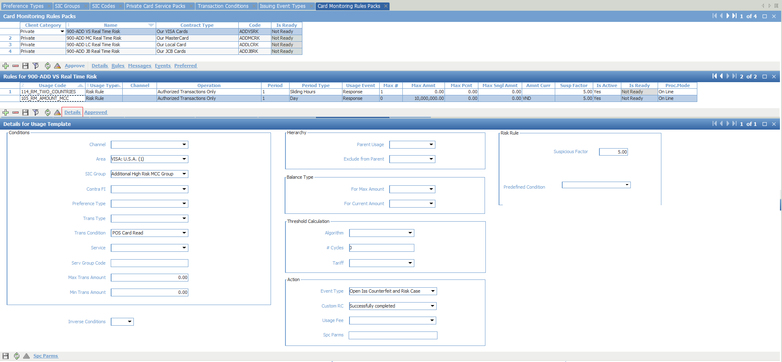

Rule 2: OCB fill in here

Rule 3: …

## Technical Detail

Above Rules are setup by WAY4 standard function.

## Limitations

* WAY4 does not support intelligent fraud monitoring (neural network)
* WAY4 does not support sound alert.